**A REPORT ON**

**TECHNIQUES TO IMPROVE GROUND WATER LEVEL**

by

Ch. Saiteja – 13BCE1032

D. Shashank – 13BCE1036

M. Akhil – 13BCE1078

Om Shree – 13BCE1086

Sandeep – 14BEC1060

**CHY104 ENVIRONMENTAL STUDIES**

**Acknowledgement**

We owe a great many thanks to many people who have constantly supported me during the Project.

We express our profound gratitude and deep regards to my guide and EVS Teacher Dr.Prabhakaran D for his exemplary guidance, constant encouragement and for correcting various documents with attention and care throughout the course of this Project. He has taken the pain to go through the Project and make necessary changes as and when required.

We would also like to express our thanks and gratitude to the research work of geologist D. NARAYANA RAO taken as reference for information regarding this project.

This is a report which explains various ARTIFICAL RECHARGE TECHNIQUES

We welcome any additional information or suggestion provided to us for improvement of our project.

**Table of contents:**

1. Background
2. Topics to be discussed
3. Description of topic with case studies
4. Application in Tamil Nadu state
5. Harvesting in past
6. Opinions of geologists
7. Conclusion
8. Recommendation
9. Bibliography

**Background**

* Ground water resource gets naturally recharged through percolation.
* But due to indiscriminate development and rapid urbanization, exposed surface for soil has been reduced drastically with resultant reduction in percolation of rainwater, thereby depleting ground water resource.

**Why Artificial Recharge??**

* In most low rainfall areas of the country the availability of utilizable surface water is so low that people have to depend largely on ground water for agriculture and domestic use.
* The problem has been further compounded due to large-scale urbanization and growth of mega cities, which has drastically reduced open lands for natural recharge.
* In hard rock areas there are large variations in ground water availability even from village to village.
* In order to improve the ground water situation it is necessary to artificially recharge the depleted ground water aquifers.

**Overview of Artificial recharge methods:**

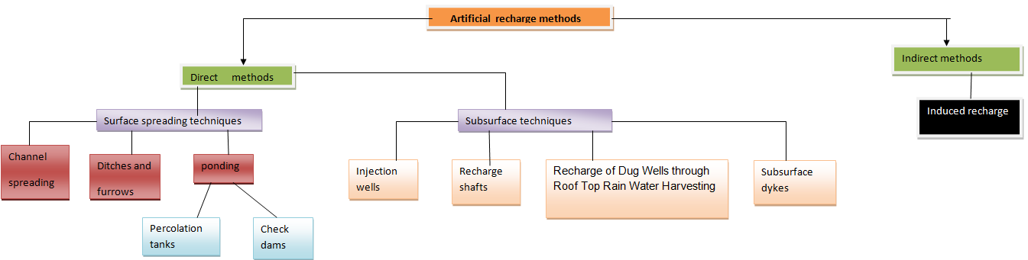

**Surface Spreading Techniques**

**Percolation Tank:**

* The downward movement of the water through the soil due to force of gravity is termed as Percolation
* Percolation tank is an artificially created surface water body, submerging in its reservoir a highly permeable land, so that surface runoff is made to percolate and recharge the ground water storage.
* Percolation tank should be constructed preferably on second to third order steams, located on highly fractured and weathered rocks, which have lateral continuity downstream.
* The recharge area downstream should have sufficient number of wells and cultivable land to benefit from the augmented ground water.

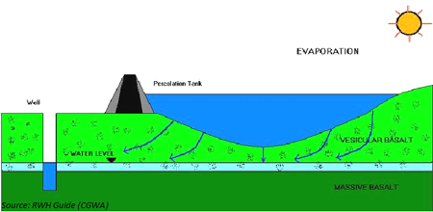

* The size of percolation tank should be governed by percolation capacity of strata in the tank bed. Normally percolation tanks are designed for storage capacity of 0.1 to 0.5 MCM. It is necessary to design the tank to provide a ponded water column generally between 3 & 4.5 m.
* The percolation tanks are mostly earthen dams with masonry structure only for spillway. The purpose of the percolation tanks is to recharge the ground water storage and hence seepage below the seat of the bed is permissible.

**Case study:**

* Three Percolation tanks at Manikpur , Benoda and Bhimdi with gross storage capacity varying from 71 to 221 TCM have been constructed.
* The recharge to ground water from percolation tanks varied from 49 to 132 TCM during 1997-98. These tanks contained water for 180 to 252 days. Around 60 to 120 ha of area downstream of percolation tanks was benefited by the recharge from percolation tanks. Around 1-4m, 4-9m, and 6-10m rise in water levels was observed during 1997-98.
* In Maharashtra there is legislation to cover percolation tanks. The water is not used for surface irrigation. In Tamil Nadu, where there is over-exploitation of ground water, farmers are now volunteering to spare land for percolation tanks. In the Saurashtra region of Gujarat these tanks are constructed for recharging wells that support peanut production.

**Percolation losses:**

* Percolation losses: When rainfall is high and water holding capacity of soil is less, the losses due to percolation are very great. Such losses are very rapid particularly when the soils are sandy and porous e.g., in case of lateritic soil in Konkan region, the soil is quite workable within a few hours even after a heavy rainfall. Besides rapid percolation of water there is also a heavy loss of plant nutrients viz., Ca, Mg, S, K, etc., resulting in soil becoming acidic

**Ditch and Furrow system:**

* In areas with irregular topography, ditches or furrows provide maximum water contact area for recharge.
* This technique consists of a system of shallow flat bottomed and closely spaced ditches / furrow which are used to carry water from source like stream /canals and provide more percolation opportunity. This technique required less soil preparation and is less sensitive to silting. Generally three pattern of Ditch & furrow system are adopted

(i) lateral

(ii) dendritic & s

(iii) contour.

* In area of low-transmissibility the density of ditch & furrow will be high.



**Channel Spreading:**

* This involves constructing small ‘L’ shaped bunds within a stream channel so that water moves along a longer path thereby improving natural recharge

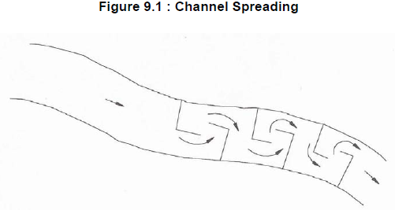

**Check Dams:**

* In this method water from rivers and streams is harvested and used for recharge of ground water and other irrigation purposes.

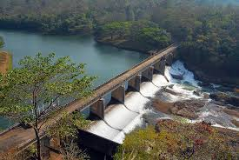

Check-dam system design has to fulfil several purposes:

1. To prevent flooding i.e. to ensure the check dam system can withstand rainstorms.

2. To guarantee harvest from the dam farmland i.e. to reduce the loss of crops due to rainstorms.

3. To conserve floodwater and sediment by impounding.

4. To ensure that increase in height and repair of the dams after prolonged use are unnecessary.

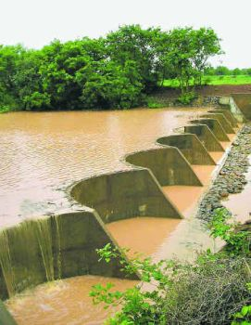

* Check dams are constructed across small streams having gentle slope. The site selected should have sufficient thickness of permeable bed or weathered formation to facilitate recharge of stored water within short span of time.
* The water stored in these structures is mostly confined to stream course and the height is normally less than 2 m and excess water is allowed to flow over the wall.
* To harness the maximum run off in the stream, series of such check dams can be constructed to have recharge on regional scale.

**Case study:**

**Location** : Tumar Watershed, Mandsaur district, M.P

Structures : Roopawali check dam ,Kheda check dam

Expenditure : Rs. 23.48 lakhs

Implementing Agency : Water Resources Department, Govt. of M.P.

Geology : Basalt

To study impact of these structures, water levels were recorded from June, 2000 to 2005.

Water level trend analysis of observation wells located at village Roopawali reveals that there is a rise in water level in both pre & post –monsoon periods

with rising rate 15cm/year and 22 cm/ year respectively.

Water level at village Kheda shows a rising trend of 14cm/ year during post-monsoon.

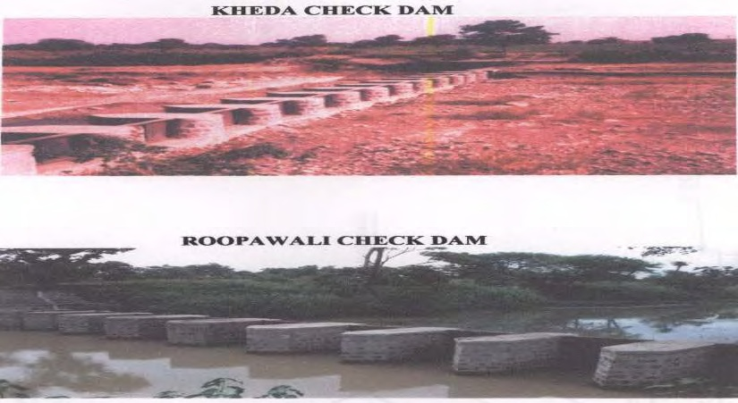

**Roof Top Rain water Harvesting:**

* In alluvial as well as hard rock areas, there are thousands of dug wells, which have either gone dry, or the water levels have declined considerably.
* These dug wells can be used as structures to recharge the ground water reservoir
* Storm water, tank water, canal water etc. can be diverted into these structures to directly recharge the dried aquifer.

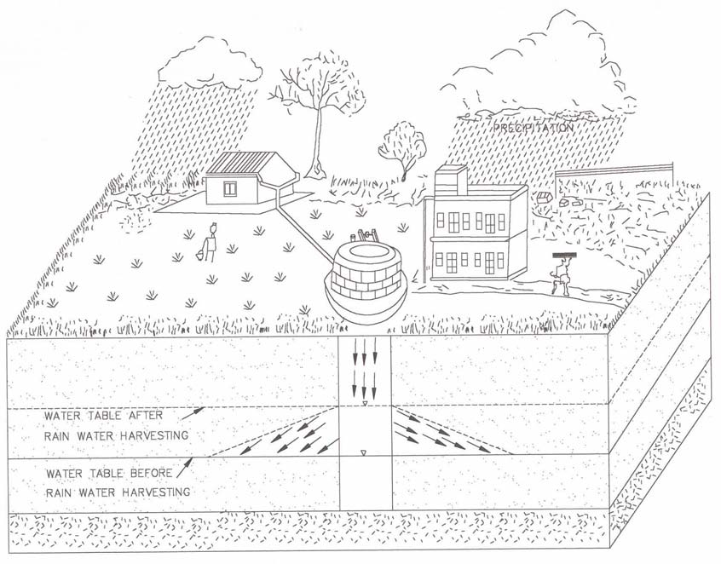

* The recharge water is guided through a pipe to the bottom of well, below the water level to avoid scouring of bottom and entrapment of air bubbles in the aquifer.
* The quality of source water including the silt content should be such that the quality of ground water reservoir is not deteriorated.

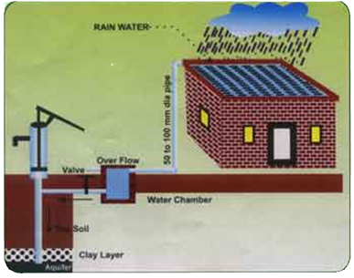

* The existing abandoned hand pumps may be used for recharging the shallow/deep aquifers, if the availability of water is limited. These are suitable for roof top area upto 150 sqm. The harvested water should be made to pass through filter media before discharging it into hand pumps

**Dug Wells:**

* Existing abandoned dug wells may also be used after cleaning and de-silting the same. Collected runoff water should be made to pass through filter media before putting into dug well.

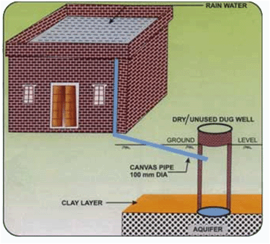

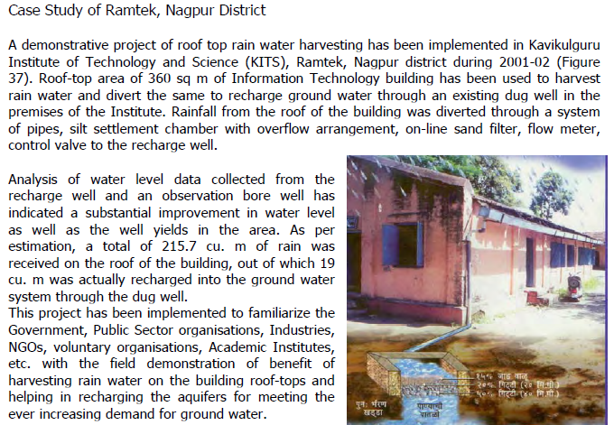

**SUB SURFACE SPREADING TECHNIQUES**

**Sub surface Dykes:**

* A **subsurface dyke** is a barrier impermeable to water that is placed underground to control the groundwater flow in an aquifer, and to raise the water table
* Sub surface dyke or under-ground dam is a subsurface barrier across stream which retards the base flow and stores water upstream below ground surface. By doing so, the water levels in upstream part of ground water dam rises saturating otherwise dry part of aquifer.
* The site where sub-surface dyke is proposed should have shallow impervious layer with wide valley and narrow out let.
* After selection of suitable site, a trench of 1-2 m wide is dug across the breadth of stream down to impermeable bed. The trench may be filled with clay or brick/ concrete wall upto 0.5m. below the ground level.
* Since the water is stored within the aquifer, submergence of land can be avoided and land above the reservoir can be utilized even after the construction of the dam. No evaporation loss from the reservoir and no siltation in the reservoir takes place. The potential disaster like collapse of the dams can also be avoided.
* For ensuring total imperviousness, PVC sheets of 3000 PSI tearing strength at 400 to 600 gauge or low-density polythene film of 200 gauges can also be used to cover the cut out dyke faces.

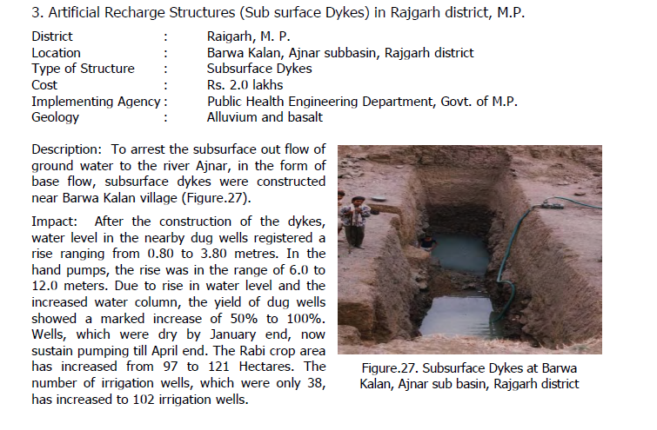

**Injection Wells (Aquifier Recharge):**

* Injection wells are structures similar to a tube well but with the purpose of augmenting the ground water storage of a confined aquifer by pumping in treated surface water under pressure .
* The injection wells are advantageous when land is scarce

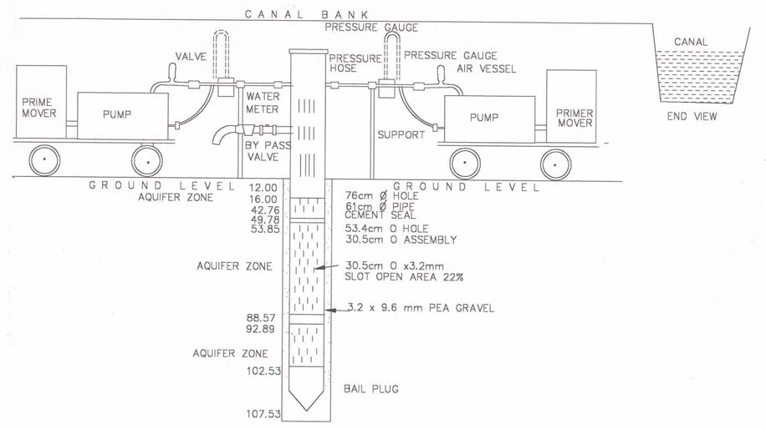

* Recharge by injection is the only method for artificial recharge of confined aquifers or deep-seated aquifers with poorly permeable overburden.
* In this method recharge is done by injecting water directly into deep aquifers through pipes or shafts.
* Dual-purpose injection wells i.e. injection cum pumping wells are more efficient.

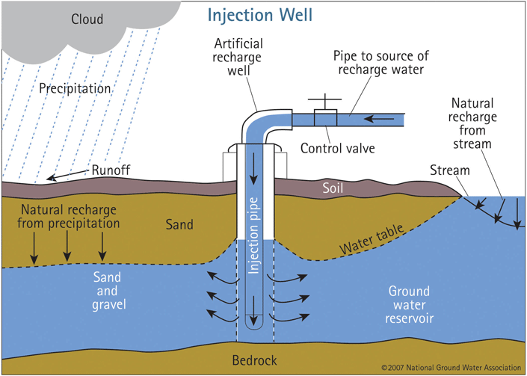

**Recharge Shafts:**

* For recharging the shallow aquifers which are located below clayey surface at a depth of about 10 to 15 m, recharge shafts of 2 to 3 m diameter and 10 to 15 m deep are constructed depending upon availability of runoff.
* These are back filled with boulders, gravels and coarse sand.

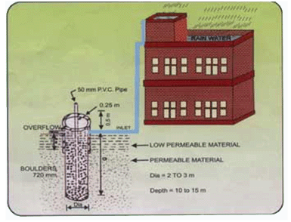

VERTICAL RECHARGE SHAFT WITHOUT INJECTION WELL:

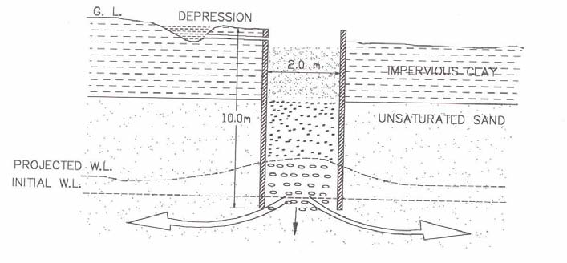

• Ideally suited for deep water levels (up to 15 m bgl).

• Presence of clay is encountered within 15 m.

• Effective in the areas of less vertical natural recharge.

• **Effective with silt water** also (using inverted filter consisting of layers of sand, gravel and boulder).

• Depth and diameter depends upon the depth of aquifer and volume of water to be recharged.

• The rate of recharge depends on the aquifer material and silt content in the water.

• The rate of recharge with inverted filter ranges from 7-14 lps for 2-3 m diameter.

This type of shaft has been constructed in the following places:

• Brahm Sarovar, Kurukshetra district, Haryana - silt free water

• Dhuri drain, Sangrur district, Punjab - surface runoff with heavy silt

• Dhuri link drain, Sangrur district, Punjab - surface runoff with heavy silt

• President Estate, New Delhi - roof top and surface runoff

• Nurmahal block, Jalandhar district, Punjab

• Kirmich and Samastipur, Kurukshetra district - surface water from depression

VERTICAL RECHARGE SHAFT WITH INJECTION WELL:

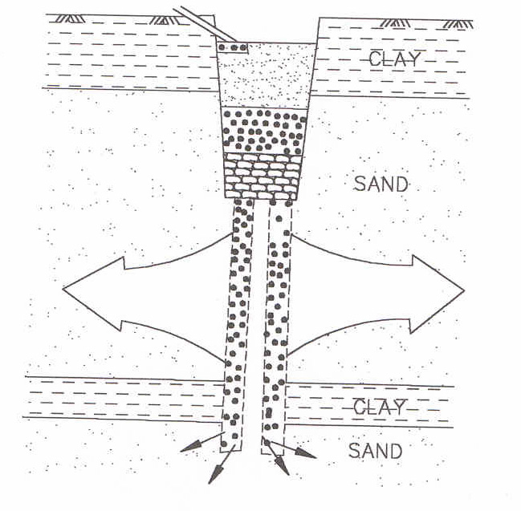

* In this technique an injection well of 100-150 mm diameter is constructed at the bottom of the shaft piercing through the layers of impermeable horizon to the potential aquifers to be reached about 3 to l5 m below the water level.

LATERAL RECHARGE SHAFTS:

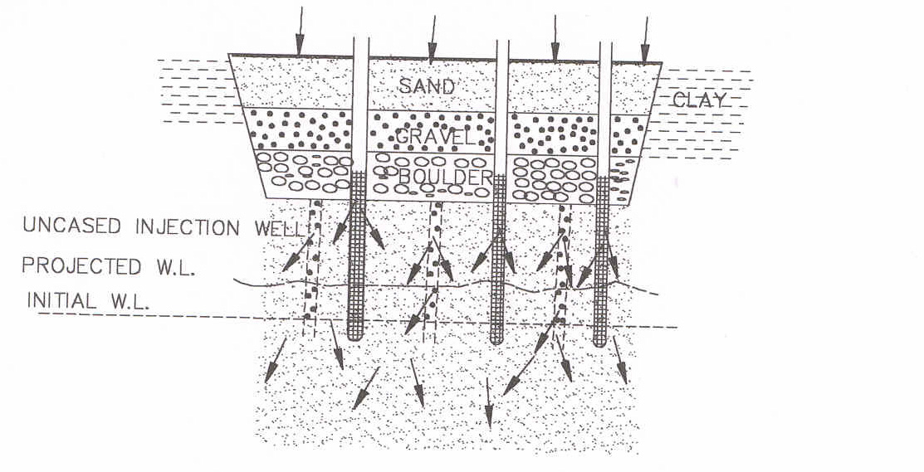

* For recharging upper as well as deeper aquifers, lateral shaft of 1.5 to 3 m wide and 10 to 30 m long depending upon the availability of water with one or more bore wells may be constructed.
* It is back filled with boulders, gravels & coarse san
* Size of storage cum filter tank varies from place to place and depends upon the available run off water from catchment.
* Depth of tubewell also varies from place to place and is normally taken down to the first granular saturated sandy formation.

This structure has been constructed in the following places:

* Dhuri drain, Sangrur district, Punjab - 300 m (with 6 injection wells)

• Dhuri link drain, Sangrur district, Punjab - 250 m (with 3 injection wells)

• Garhi Kangran, Baghpat district, U.P. - 15 m (with 2 injection wells)

• Shram Shakti Bhawan, New Delhi - 15 m (3 lateral shafts with 2 injection well in

each)

• Dhaneta, Samana block, Patiala district, Punjab - 4 lateral shafts with injection wells

• D.C. Office Complex, Faridabad, Haryana - with injection wells

• Lodhi Garden, New Delhi - with injection wells

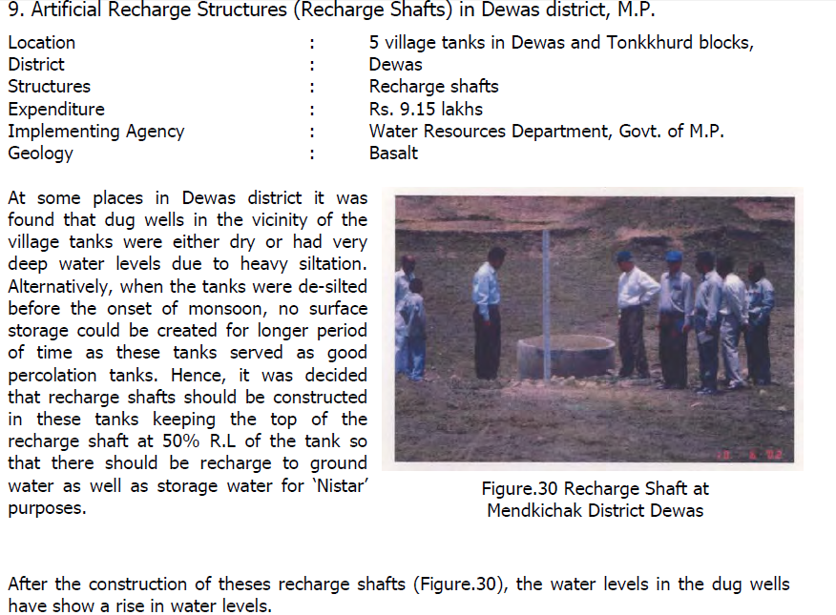

**INDIRECT METHODS – INDUCED RECHARGE**

* It is an indirect method of artificial recharge involving pumping from aquifer, hydraulically connected with surface water, to induce recharge to the ground water reservoir.
* When the cone of depression intercepts river recharge boundary a hydraulic connection gets established with surface source, which starts providing part of the pumpage yield.
* In such methods, there is actually no artificial build up of ground water storage but only passage of surface water to the pump through an aquifer.
* In hard rock areas the abandoned channels often provide good sites for induced recharge.
* The greatest advantage of this method is that under favourable hydrogeological situations the quality of surface water generally improves due to its path through the aquifer material before it is discharged from the pumping well.
* For obtaining very large water supplies from riverbed, lakebed deposits or waterlogged areas, collector wells are constructed.
* In India such wells have been installed in Yamuna bed at Delhi and other places in Gujarat, Tamil Nadu and Orissa.
* The large discharges and lower lift heads make these wells economical even if initial capital cost is higher as compared to tubewell.

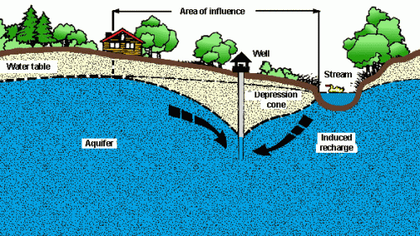

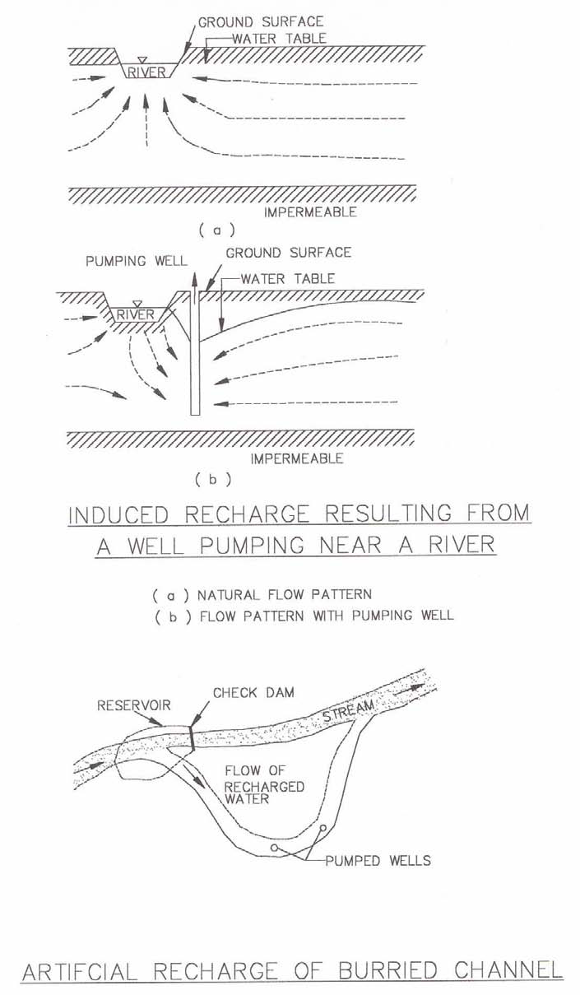

* This method of induced recharge consists of setting a gallery or a line of wells parallel the bank of a river and at a short distance from it.
* Without the wells there would be unimpended outflow of groundwater to the river. When small amounts of groundwater are withdrawn from the gallery parallel to the river, the amount of groundwater discharged into the river decreases.
* The water recovered by the gallery consists wholly of natural groundwater. Each groundwater withdrawal is accompanied by a drawdown in the water table. For high recovery rates this drawdown tends to lower the groundwater table at the shoreline below that at the river.
* Thus, surface water from the river will be induced to enter the aquifer and to flow into the gallery. In areas where the stream is separated from the aquifer by materials of low permeability, leakage from the stream may be so small that the system is not feasible.

Conjunctive well:

A conjunctive well is one that is screened in both a shallow confined aquifer and a deeper artesian aquifer. Water is pumped from the deeper aquifer and if its potentiometric surface is lowered below the shallow water table, water from the shallow aquifer drains directly into the deeper aquifer. Water augmentation by conjunctive wells has the advantage of utilizing sediment-free groundwater which greatly reduces the damage of clogging well screens.

Other benefits are:

* It reduces the amount of evapotranspiration water loss from the shallow water table.
* Reduces flooding effects in some places.

Environmental effects from the conjunctive well method must be carefully studied to assure that unwanted dewatering of wetlands or reduction of base flow will not occur. The possibility of coagulation due to mixing of chemically different groundwater should also be investigated.

**IMPACT OF ARTIFICIAL RECHARGE STRUCTURES IN TAMIL NADU STATE**

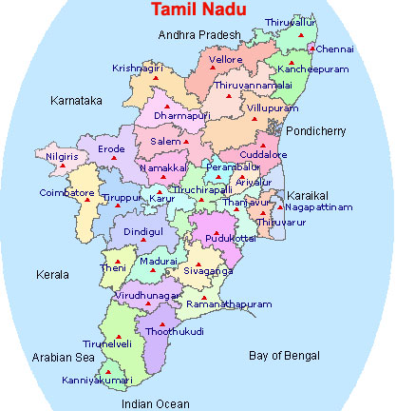

* Tamil Nadu state covers an area of 1,30,058 km2. The average annual rainfall of the state is about 995 mm.
* Nearly 73% of the total area of the State is occupied by a variety of hard & fissured crystalline rocks like charnockite, gneisses and granites.
* The **depth of open wells** varies from 6 to 30mbgl. While the **depth of borewells** generally varies from 30-100m.
* The yield of **wells in the alluvium varies** form 27 to 212 m3/hr.
* The yield of **wells in the fissured formations** varies from 7 to 35 m3/hr.
* The annual replenishable groundwater resource of the state is 23.07 bcm with a net annual groundwater availability of 20.76 bcm.
* Ground water draft (as on 31st march 2004) is 17.65 bcm with a stage of ground water development of 85%.
* Out of the 385 assessment units in the state, 142 blocks has been categorised as overexploited and 33 blocks have been categorised as critical from ground water development point of view.

Artificial Recharge structures suitable for the state:

* The Tamil Nadu state has diversified geological features, from the archeans to the recent formation with major portion occupied by consolidated formations.
* **Check dams/nalla plugs/ gully plugs and percolation ponds** are suited for these consolidated formations.
* **Recharge pits and recharge shafts with tubewells** are ideally suited for the semiconsolidated and unconsolidated formations.
* For urban **areas roof top rainwater harvesting** and artificial recharge structure like the **recharge pit and recharge shafts with/without tube wells** are feasible.

Under Central Sector Scheme, construction of sub-surface dykes on experimental/operational basis was taken up at three locations in Tamil Nadu. The details of villages where these structures have been shown below:

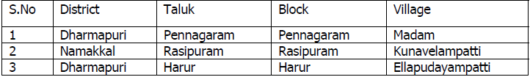

Advantage of sub-surface dykes in Tamil Nadu:

* Sub-surface dykes have the following advantages in comparison with other artificial recharge structures:
* As water is stored within the aquifer, no land is lost due to submergence and the land above the reservoir can be utilized even after construction of the structure.
* No water is lost due to evaporation.
* There is no siltation and consequent reduction in storage capacity.
* There is no potential disaster like collapse as in the case of surface reservoirs.

The impacts of different structures are enumerated below:

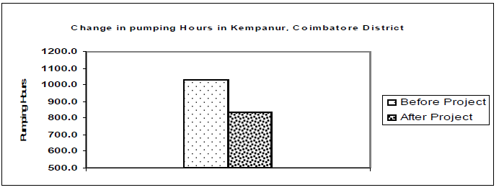

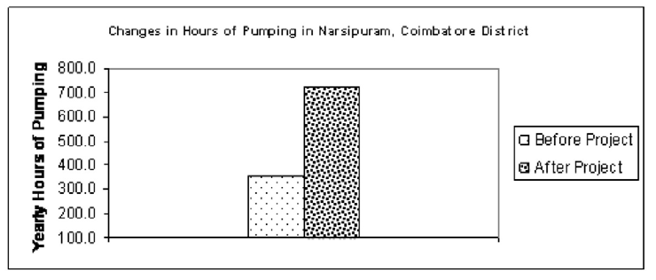

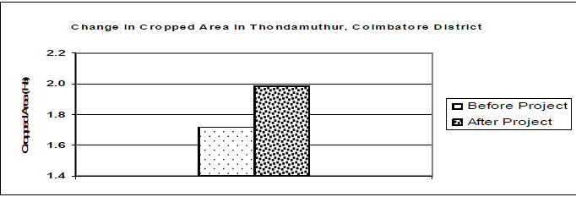

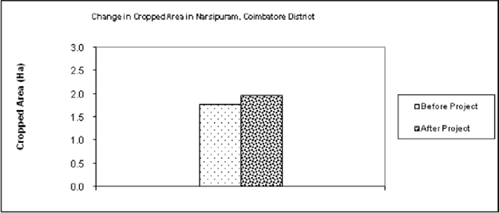

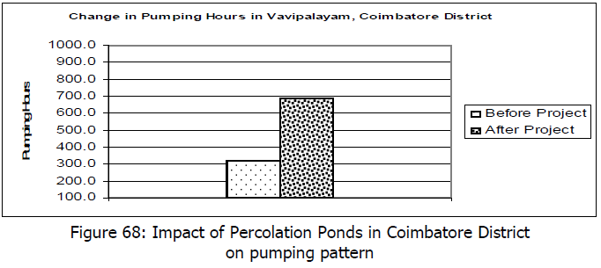

* March 22nd was world water day.
* Objective of celebrating such a day is to raise awareness not only about water , but also to show how water and energy are interlinked indepently.

**Harvesting in Past:**

* More than 7000 years ago people of India knew about water harvesting.
* Many harvesting techniques like
* **kere**- storage tanks
* **phad**-embankments,
* **kund** –large domes
* **Naula**-stone lined tank catches dripping water near springs and trees.
* **Zing**-storages for glacial water
* **Bamboo drip system**-network of bamboo pipes are used to collect water from hill springs.
* **Surangas** –vertical excavations that collect water flowing down the slopes.

**Opinions of Geologists:**

* It has been known to us that for domestic purposes like in case of apartments water recharge pit points have been suggested for improvement in ground water level.
* The water recharge pit point helps really in when the bore wells get dried up during summer.
* In Hyderabad it has been made compulsory to have a water recharge pit for an apartment.

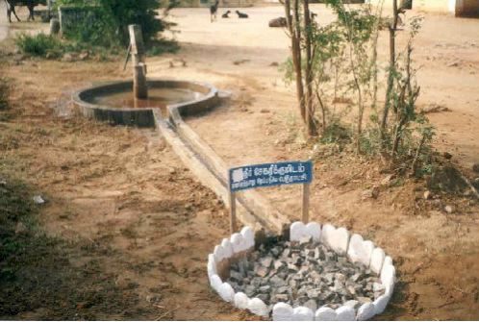

* For agricultural purposes check dams are constructed across rivers .
* These help in recharging of surrounding bore wells in agricultural fields.

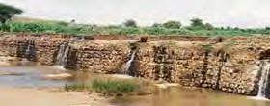

**Advantages of artificial recharge:**

* The technology is appropriate and generally well understood by both the technologists and the general population.
* Recharge can significantly increase the sustainable yield of an aquifer.
* Recharge methods are environmentally attractive, particularly in arid regions.
* Most aquifer recharge systems are easy to operate.
* In many river basins, control of surface-water run-off to provide aquifer recharge reduces sedimentation problems.
* The use of aquifers for storage and distribution of water and removal of contaminants by natural cleaning processes which occur as polluted rain and surface water infiltrate the soil and percolate down through the various geological formations.
* The technology is appropriate and generally well understood by both the technicians and the general population.
* Very few special tools are needed to dig drainage wells.
* In rock formations with high, structural integrity few additional materials may be required (concrete, softstone or coral rock blocks, metal rods) to construct the wells.
* Groundwater recharge stores water during the wet season for use in the dry season, when demand is highest.
* Aquifer water can be improved by recharging with high quality injected water.
* Recharge can significantly increase the sustainable yield of an aquifer.
* Recharge methods are environmentally attractive, particularly in arid regions.
* Most aquifer recharge systems are easy to operate.
* In many river basins, control of surface water runoff to provide aquifer recharge reduces sedimentation problems.
* Recharge with less-saline surface waters or treated effluents improves the quality of saline aquifers, facilitating the use of the water for agriculture and livestock.

**Dis-advantages of Artificial Recharge:**

* In the absence of financial incentives, laws, or other regulations to encourage landowners to maintain drainage wells adequately, the wells may fall into disrepair and ultimately become sources of groundwater contamination.
* There is a potential for contamination of the groundwater from injected surface-water run-off, especially from agricultural fields and road surfaces. In most cases, the surface-water run-off is not pre-treated before injection.
* Recharge can degrade the aquifer unless quality control of the injected water is adequate.
* Unless significant volumes of water are injected in an aquifer, groundwater recharge may not be economically feasible.
* In the absence of financial incentives, laws, or other regulations to encourage landowners to maintain drainage wells adequately, the wells may fall into disrepair and ultimately become sources of groundwater contamination.
* There is a potential for contamination of the groundwater from injected surface water runoff, especially from agricultural fields and roads surfaces. In most cases, the surface water runoff is not pre-treated before injection.
* Recharge can degrade the aquifer unless quality control of the injected water is adequate.
* Unless significant volumes can be injected into an aquifer, groundwater recharge may not be economically feasible.
* The hydrogeology of an aquifer should be investigated and understood before any future full-scale recharge project is implemented. In karstic terrain, dye tracer studies can assist in acquiring this knowledge.
* During the construction of water traps, disturbances of soil and vegetation cover may cause environmental damage to the project area.
* Hence we strongly recommend to increase ground water level for domestic purposes by RTRWH etc,..
* As an individual we should try our level best for sustainability of ground water levels for future generations without compromising their needs by implementing recharge methods.

Bibliography:

* [https://www.google.co.in/search?q=injection+well+for+groundwater+recharge&newwindow=1&source=lnms&tbm=isch&sa=X&ei=YR4rU6buD4GJrAe63oDgCg&ved=0CAgQ_AUoAQ&biw=1366&bih=667#imgdii=_](https://www.google.co.in/search?q=injection+well+for+groundwater+recharge&newwindow=1&source=lnms&tbm=isch&sa=X&ei=YR4rU6buD4GJrAe63oDgCg&ved=0CAgQ_AUoAQ&biw=1366&bih=667)
* Samvardhan%20Water%20Harvest%20Systems.htm
* <http://www.slideshare.net/cpkumar/hydrologic-design-of-a-percolation-tank-2490249>
* <http://en.wikipedia.org/wiki/Water_pipe_percolator>
* Interviews,THE HINDU newspaper